

REGRESSION ANALYSIS OF DETERMINANTS OF INFANT MORTALITY

CASE STUDY 3:
UN Sustainable Development Goals (SDG) Database

SUBMITTED BY -
Amaya Mary Anil – 2441404
Aryan Sarin - 2441411
Dhara Dhoshi - 2441415

ACKNOWLEDGEMENT
We would like to express our sincere gratitude to Dr. Lakshmi R, our Linear Regression Modelling professor, for her constant guidance, valuable insights, and encouragement throughout the development of this case study. Her expertise and support helped us better understand the concepts and apply them effectively in our work.
We also extend our heartfelt thanks to the Department of Statistics and Data Science for organizing such meaningful skill enhancement initiatives that allow students to gain practical exposure and strengthen their analytical abilities.
We are equally grateful to all the team members who collaborated and contributed their time, effort, and ideas to successfully complete this case study.
Through this work, we sincerely hope that we were able to uphold Christ University’s vision of Excellence and Service, by striving for academic rigor, teamwork, and responsible learning.

INDIVIDUAL CONTRIBUTION
Amaya worked on the Exploratory Data Analysis and collection of data and the report.
Aryan worked on the collection of data, preprocessing of the data and data modelling using multi-linear regression model
Dhara worked on the residual analysis of the model and made the presentation and helped with the report.
INTRODUCTION
The United Nations Sustainable Development Goals (SDGs) were introduced in 2015 to improve living conditions and promote overall development across countries. Among the 17 goals, Goal 3 – Good Health and Well-being focus on improving healthcare services and reducing death rates, especially among mothers and infants.
Health indicators such as Infant Mortality Rate, Maternal Mortality Ratio, and Skilled Birth Attendance are used to understand the quality of healthcare in different countries. Infant and maternal mortality reflect the effectiveness of medical care, while skilled birth attendance shows the availability of trained healthcare professionals during childbirth.
This study analyzes the relationship between these indicators using global data from the UN SDG Database. The aim is to understand how better maternal healthcare and professional medical support can help reduce infant mortality.

OBJECTIVES
- To understand the importance of SDG Goal 3 – Good Health and Well-being using global health indicators.
- To study the trend of infant mortality using data from the UN SDG database.
- To examine the effect of skilled birth attendance on infant mortality.
- To analyze the relationship between maternal mortality and infant mortality.
- To build a regression model to identify key factors affecting infant mortality.

DATASET DESCRIPTION
The data used in this study was collected from the United Nations Sustainable Development Goals (SDG) Database. The datasets include country-wise yearly information related to important health indicators under SDG Goal 3 – Good Health and Well-being, covering the period 2010 to 2023.
After cleaning and merging the datasets, the final dataset consisted of 1,772 observations and 5 variables.

Indicators Used -
- Infant Mortality Rate: Number of infant deaths per 1,000 live births.
- Skilled Birth Attendance: Percentage of births attended by trained health professionals.
- Maternal Mortality Ratio: Number of maternal deaths per 100,000 live births.
SL.NO | Variable | Description | Data Type
1. | Country | Name of the country | Categorical
2. | Year | Year of observation (2010-2023) | Numeric
3. | Infant Mortality | Infant deaths per 1,000 live births | Numeric
4. | Skilled Birth Attendance | Percentage of skilled birth attendance | Numeric
5. | Maternal Mortality | Maternal deaths per 100,000 live births | Numeric

Dependent and Independent Variables

In this study, the Infant Mortality Rate is considered the dependent variable because it is the main outcome being analyzed. Skilled Birth Attendance and Maternal Mortality Rate are taken as independent variables since both reflect the quality of healthcare available to mothers and newborns and are expected to directly influence infant survival.

METHEDOLOGY
# LOADING LIBRARIES
library(readxl)
library(tidyr)
library(dplyr)
library(ggplot2)
library(lmtest)

# IMPORTING AND FILTERING DATASETS
imr <- read_excel("C:/Users/amaya/Downloads/SH_DYN_IMRT.xlsx")
imr <- imr %>% filter(Sex == "BOTHSEX")
imr_long <- imr %>%
pivot_longer(cols = matches("^20"),
names_to = "Year",
values_to = "InfantMortality") %>%
select(GeoAreaName, Year, InfantMortality)
colnames(imr_long)[1] <- "Country"
sba <- read_excel("C:/Users/amaya/Downloads/SH_STA_BRTC.xlsx")
sba_long <- sba %>%
pivot_longer(cols = matches("^20"),
names_to = "Year",
values_to = "SkilledBirth") %>%
select(GeoAreaName, Year, SkilledBirth)
colnames(sba_long)[1] <- "Country"
mmr <- read_excel("C:/Users/amaya/Downloads/SH_STA_MORT.xlsx")
mmr_long <- mmr %>%
pivot_longer(cols = matches("^20"),
names_to = "Year",
values_to = "MaternalMortality") %>%
select(GeoAreaName, Year, MaternalMortality)
colnames(mmr_long)[1] <- "Country"
data <- imr_long %>%
left_join(sba_long, by = c("Country", "Year")) %>%
left_join(mmr_long, by = c("Country", "Year"))
data <- na.omit(data)
data$Year <- as.numeric(data$Year)
data$InfantMortality <- as.numeric(data$InfantMortality)
data$SkilledBirth <- as.numeric(data$SkilledBirth)
data$MaternalMortality <- as.numeric(data$MaternalMortality)

# INTERPRETATION-
The three datasets related to infant mortality, skilled birth attendance, and maternal mortality were first cleaned and converted into a suitable format for analysis. The data was reshaped from wide to long format to make year-wise comparisons easier, then merged using the common variables, namely Country and Year. Missing values were removed, and all variables were converted into numeric form to ensure accuracy. These steps helped create a clean and structured dataset ready for statistical and regression analysis.

# SUMMARY STATISTICS
summary(data)
## Country Year InfantMortality SkilledBirth
## Length:1772 Min. :2010 Min. : 1.70 Min. : 10.00
## Class :character 1st Qu.:2013 1st Qu.: 5.40 1st Qu.: 88.78
## Mode :character Median :2016 Median : 13.60 Median : 98.30
## Mean :2016 Mean : 18.76 Mean : 90.58
## 3rd Qu.:2019 3rd Qu.: 27.73 3rd Qu.: 99.70
## Max. :2023 Max. :124.30 Max. :100.00
## MaternalMortality
## Min. : 1.091
## 1st Qu.: 11.111
## Median : 44.732
## Mean : 115.268
## 3rd Qu.: 130.892
## Max. :1650.190

# INTERPRETATION-
The average infant mortality rate is 18.76 deaths per 1,000 live births, while the average skilled birth attendance is 90.58%, showing that most deliveries are handled by trained professionals. The average maternal mortality rate is 115.27 deaths per 100,000 live births, but the large range in values indicates major differences in healthcare quality across countries.

# REGRESSION MODEL
model <- lm(InfantMortality ~ SkilledBirth + MaternalMortality, data = data)
summary(model)
##
## Call:
## lm(formula = InfantMortality ~ SkilledBirth + MaternalMortality,
## data = data)
##
## Residuals:
## Min 1Q Median 3Q Max
## -33.431 -5.113 -1.449 3.476 37.392
##
## Coefficients:
## Estimate Std. Error t value Pr(>|t|)
## (Intercept) 43.869554 1.943270 22.57 <2e-16 ***
## SkilledBirth -0.353966 0.019631 -18.03 <2e-16 ***
## MaternalMortality 0.060341 0.001649 36.58 <2e-16 ***
## ---
## Signif. codes: 0 '***' 0.001 '**' 0.01 '*' 0.05 '.' 0.1 ' ' 1
##
## Residual standard error: 7.329 on 1769 degrees of freedom
## Multiple R-squared: 0.8185, Adjusted R-squared: 0.8182
## F-statistic: 3987 on 2 and 1769 DF, p-value: < 2.2e-16

# INTERPRETATION-
The fitted regression model is:
Infant Mortality=43.87−0.35(Skilled Birth Attendance) +0.06(Maternal Mortality)
The model shows that for every 1% increase in skilled birth attendance, infant mortality decreases by about 0.35 deaths per 1,000 live births, indicating a strong protective effect of professional medical care and for every one-unit increase in maternal mortality, infant mortality increases by about 0.06 deaths, showing a positive relationship between the two.
The R² value of 0.8185 indicates that about 82% of the variation in infant mortality is explained by the model, suggesting a very good fit.

# DATA VISUALIZATION
# InfantMortality vs SkilledBirth
ggplot(data, aes(SkilledBirth, InfantMortality)) +
geom_point(color = "steelblue") +
geom_smooth(method = "lm", se = FALSE, color = "red") +
labs(
title = "Skilled Birth Attendance vs Infant Mortality",
x = "Skilled Birth Attendance (%)",
y = "Infant Mortality Rate")
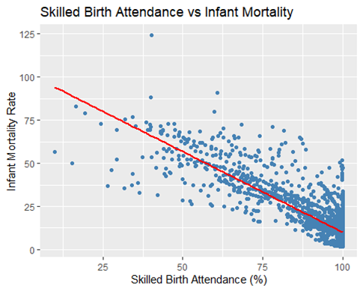
# INTERPRETATION-
The scatter plot shows a negative relationship between skilled birth attendance and infant mortality. As the percentage of skilled birth attendance increases, infant mortality tends to decrease. This indicates that better medical care during childbirth helps reduce infant deaths.
# InfantMortality vs MaternalMortality
ggplot(data, aes(MaternalMortality, InfantMortality)) +
geom_point(color = "darkgreen") +
geom_smooth(method = "lm", se = FALSE, color = "red") +
labs( title = "Maternal Mortality vs Infant Mortality",
x = "Maternal Mortality Rate",
y = "Infant Mortality Rate" )
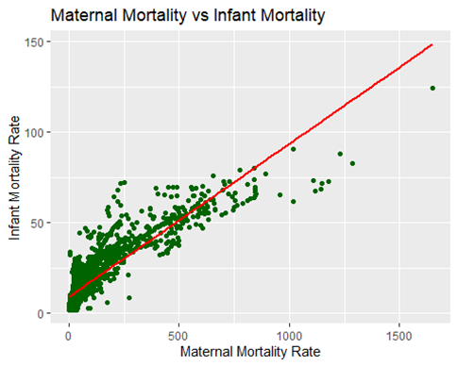
# INTERPRETATION-
This scatter plot shows a positive relationship between maternal mortality and infant mortality. Countries with higher maternal mortality generally have higher infant mortality. This suggests that poor maternal healthcare conditions also affect infant survival.

# HISTOGRAM
# DISTRIBUTION OF INFANT MORTALITY
ggplot(data, aes(x = InfantMortality)) +
geom_histogram(bins = 30,fill = "orange",color = "black",alpha = 0.7) +
labs(
title = "Distribution of Infant Mortality Rate",
x = "Infant Mortality Rate",
y = "Frequency")

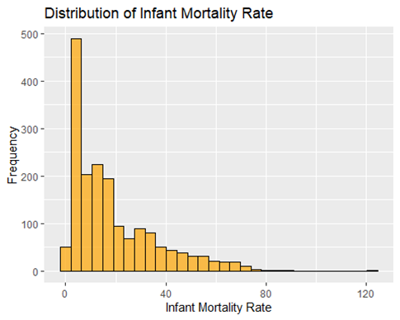
# INTERPRETATION-
The histogram shows that most countries have lower to moderate infant mortality rates, while fewer countries have very high values. This indicates that although healthcare has improved in many regions, some countries still face serious challenges in reducing infant mortality.
# RESIDUAL ANALYSIS
residual_data <- data.frame(
Fitted = fitted(model),
Residuals = resid(model)
)
# RESIDUALS VS FITTED VALUES
ggplot(residual_data, aes(x = Fitted, y = Residuals)) +
geom_point(color = "blue") +
geom_hline(yintercept = 0, color = "red") +
labs( title = "Residuals vs Fitted Values",
x = "Fitted Values",
y = "Residuals" )
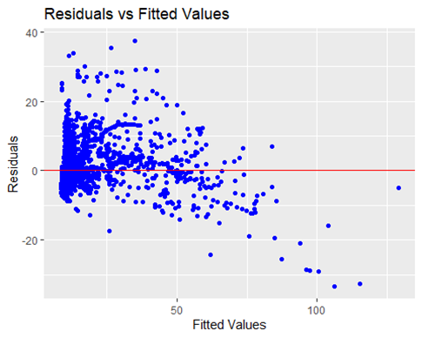

# INTERPRETATION-
The residuals are randomly scattered around zero, which shows that the mean of residuals is approximately 0 and that a linear relationship exists between X and Y. This indicates that the assumption of linearity is reasonably satisfied.

## mean(resid(model))
## bptest(model)
## [1] -5.282096e-17
##
## studentized Breusch-Pagan test
##
## data: model
## BP = 124.34, df = 2, p-value < 2.2e-16

# INTERPRETATION-
The mean of residuals is approximately zero, confirming that the regression model is unbiased, and the average error is 0. The Breusch–Pagan test indicates the presence of heteroscedasticity, meaning the residual variance is not constant

# HISTOGRAM OF RESIDUALS
ggplot(residual_data, aes(x = Residuals)) +
geom_histogram( bins = 30, fill = "orange", color = "black", alpha = 0.7 ) + labs( title = "Histogram of Residuals", x = "Residuals", y = "Frequency")
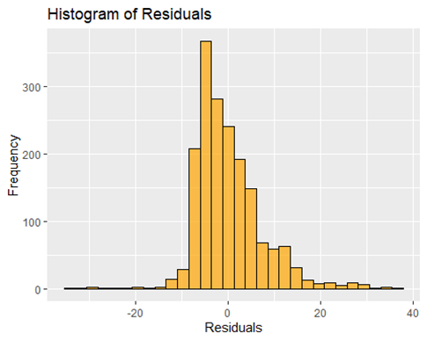
# INTERPRETATION-
The histogram shows that the residuals are approximately symmetric and centered around zero, indicating that most errors are small.

# Q-Q PLOT OF RESIDUALS
# Create residual dataframe
residual_data <- data.frame( Residuals = resid(model))
ggplot(residual_data, aes(sample = Residuals)) +
stat_qq(color = "blue") + stat_qq_line(color = "red") +
labs (title = "Q-Q Plot of Residuals",
x = "Theoretical Quantiles",
y = "Sample Quantiles")

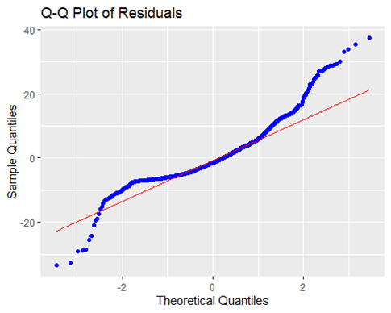

shapiro.test(residuals(model))

Shapiro-Wilk normality test

data: residuals(model)
W = 0.90628, p-value < 2.2e-16

# INTERPRETATION-
As can be observed, a S-shaped curve can be formed which is a sign that the residual is not normal. On running a Wilks-Shapiro Tests, the p-values obtained were far less than 0.05, so the assumption remained false.
REMEDIATION:
Bpox-Cox transformation was applied, which also remained insufficient in correcting heteroscedasticity and non-normality of the residuals. Further, Robust Standard Errors were applied to obtain valid inference. The coefficients remain statistically significant. Despite presence of heteroscedasticity, the use of robust standard errors ensures valid inference.
library(lmtest)
library(sandwich)

coeftest(model, vcov=vcovHC(model, type="HC1"))
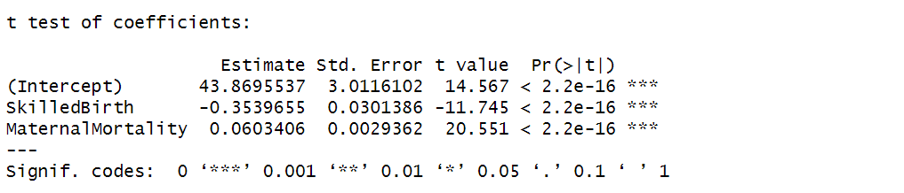
CONCLUSION
This study analyzed the relationship between infant mortality, skilled birth attendance, and maternal mortality using data from the UN Sustainable Development Goals (SDG) Database under SDG Goal 3 – Good Health and Well-being. The data was cleaned, reshaped, and merged to form a structured dataset suitable for statistical analysis. Descriptive statistics and visualizations were used to understand data patterns, followed by multiple linear regression modelling.
The regression model showed that skilled birth attendance has a significant negative effect on infant mortality, while maternal mortality has a significant positive effect, which aligns with real-world expectations. The model explained about 82% of the variation in infant mortality, indicating a strong and appropriate model fit. Residual analysis confirmed that the assumptions of linearity and mean zero errors were reasonably satisfied, although slight heteroscedasticity and non-normality were observed, however Robust Standard Errors were implemented for correct inference. Overall, the results confirm that the regression model is appropriate and reliable for explaining infant mortality trends.

IMPROVEMENTS
- Using updated data in the future can help track recent changes in health outcomes.
- Similar analysis can be extended to specific regions or groups of countries for more focused insights.
- Visualizations and interactive dashboards can be added to make results easier to understand and communicate.
- Better model specification
- More variables

